Lecture 14

**JOB Details-Resume-Development**

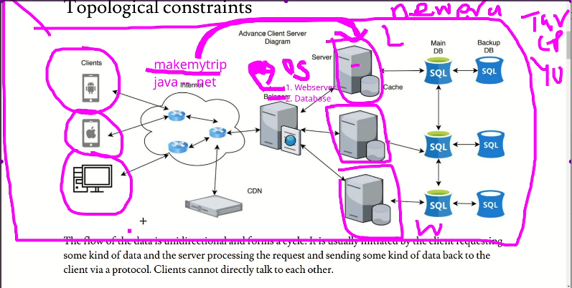

a network in an organization or industry

* 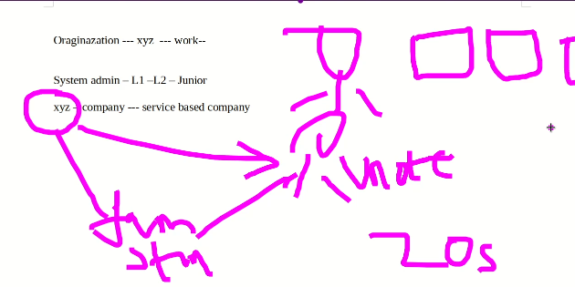
* Practical work
* 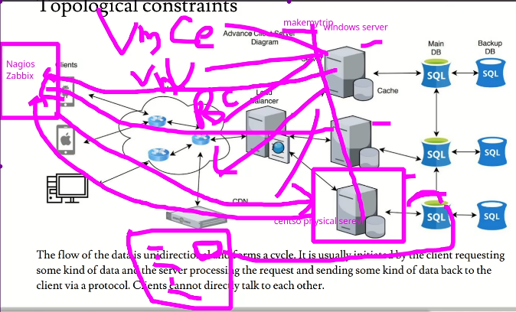
* Dashboard of a monitoring app looks like this pic below,
* 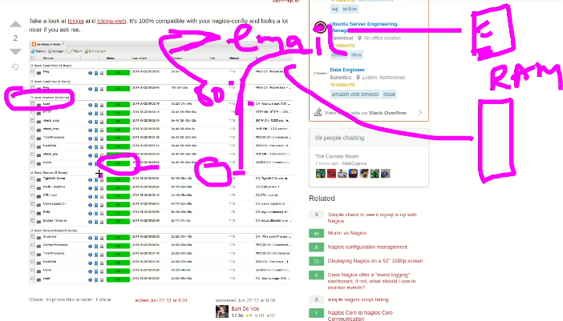
* When the load on a specific service increases more then 80% 🡪 automatically an e-mail generates to a team that is monitoring about this load 🡪 it is called thrash hold
* Similarly, if RAM is consumed more than 80% or 90% 🡪 an email is sent to the team.
* Similarly if a partition is amount to full,
  + Check it by $ df -h
  + Took back up
  + Ticket raised to seniors (if I couldn’t do it)
  + Then later on partition is extended as required
* Daily activities.
  + Monitoring of servers
  + 20 servers
  + Negios or zabixx for monitoring
  + Used LVM to extend or reduce the partition.
  + As per requirement application teams wich us to create a “mount point”
  + House keeping
    - Archive,🡪 tar, 🡪 zip
    - Backup using tape device
  + Permissions and rights as per requirement to application directory/folders
  + Patching 🡪 software update 🡪 yum
  + We maintain multiple services on servers like NFS, SMABA services, DHCP services, ftp,
  + Managed and monitor logs / var logs –journals logs
* 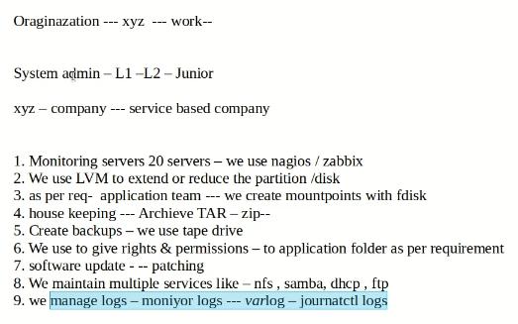
* Resumes
* Available on the portal 🡪 select a suitable one and modify accordingly.
* Prepare a resume having 2 to 3 pages at least
  + Read the resume in details
  + Avoid using educational percentage 🡪 just write education without percentage
  + Add professional summary 🡪 overall experience 🡪 total IT experience
    - Total 5 years,
    - Relevant to Linux 2 years 🡪 system admin
    - 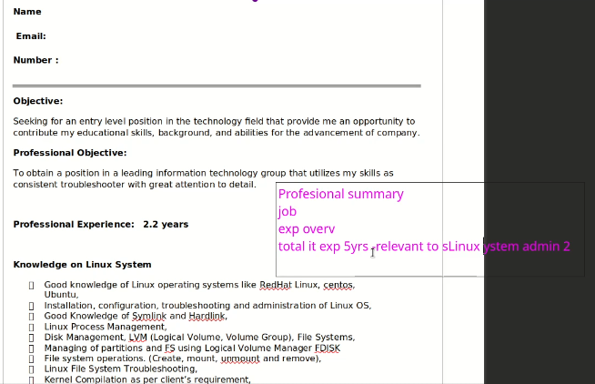
  + Add roles and responsibilities.
  + Location 🡪 don’t use to far location
    - Name
    - Email
    - Number
    - Objects
    - Professional summary
    - OS flavours – worked
    - Linux Admin Skills (at least 15 lines)
    - Cloud skills
    - Certifications (if available)
    - Roles & responsibility
    - Achievements
    - Personal details
  + After uploading resume at job portal 🡪 complete 200% 🡪 update and modify resume after 2 to 3 days.
  + Skills
    - Linux
    - Cloud
    - Troubleshooting
    - DNS
    - Web server
    - LVM
    - Monitoring
    - Python
    - Scriptinf
  + Salary 🡪(companies go for 30 to 40 % hike)🡪 demand should be 80% from current salary.
    - If HR ask that why 80%
      * Tell him the skills, eg. Cloud, cluster, DevOps, multiple knowledge
  + Make it sure to appear in the final interview.
  + Trick the HR because he’s not technical.
* Categories of applicants
  + Fresher (at least 1 year experience)
  + 2 – 5 years’ experience
  + 5 – 10 years
* Don’t write currently training or currently studying etc.
* Currently I am working XYS but I can join u at the notice of 1 month
* Experience
  + Internship 1 year (from any company which can give me reference)

Remember: No compromise over skills

* + Start applying for jobs and face interviews.